Table of Contents

**Lab Prerequisites** 2

**Goals for this Lab** 2

*Scenario : Setting up Dynamics 365 Omnichannel to communicate with Facebook Messenger and create service ticket.* 2

*Task 1 : Assigning role and permissions to the users.* 2

*Task 2 : Omnichannel Setup* 5

*Task 3 : Testing the result by triggering chat from Facebook and then create a case.* 14

Dynamics 365 Omnichannel Setup

## Lab Prerequisites

1. Office 365 Omnichannel installed
2. Facebook Account
3. Facebook Page / Messenger

## Goals for this Lab

After this lesson, you will be able to : Prepare your Dynamics 365 Omnichannel to receive and respond to Facebook Messenger.

## Scenario : Setting up Dynamics 365 Omnichannel to communicate with Facebook Messenger and create service ticket.

## *Task 1 : Assigning role and permissions to the users.*

1. Go to admin.powerplatform.microsoft.com, and choose the correct environment.

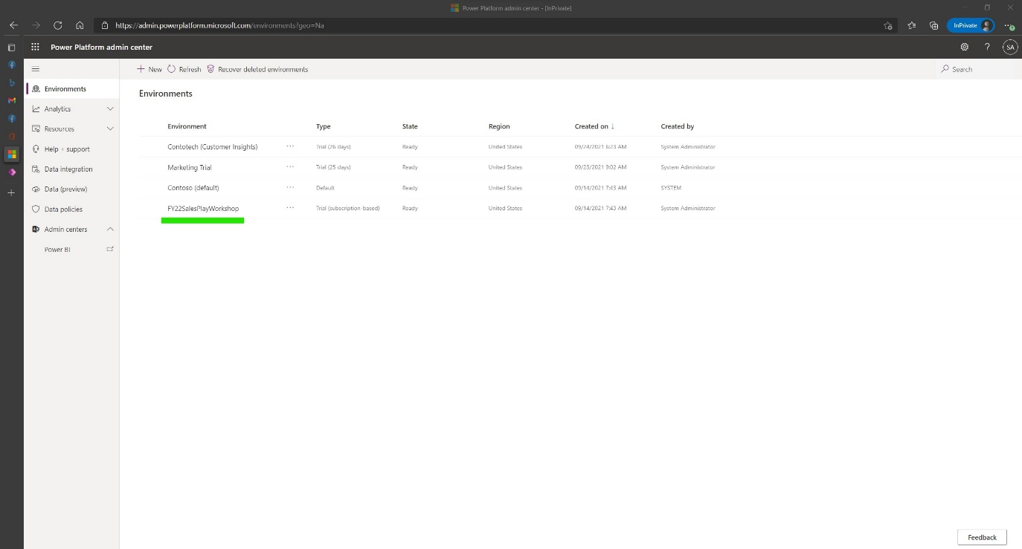

1. In your environment setup page, navigate to Users, click ‘See all’.  
     
   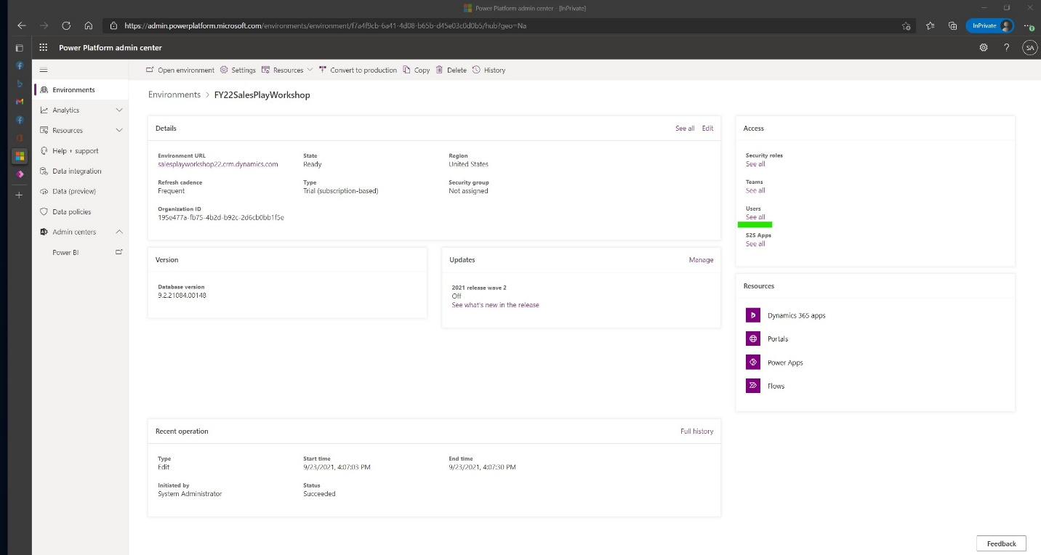
2. Click ‘Add user’. Then search the user that you want to assign roles to.   
     
   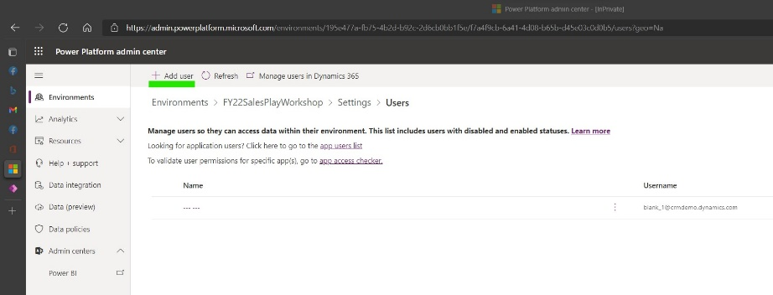  
     
   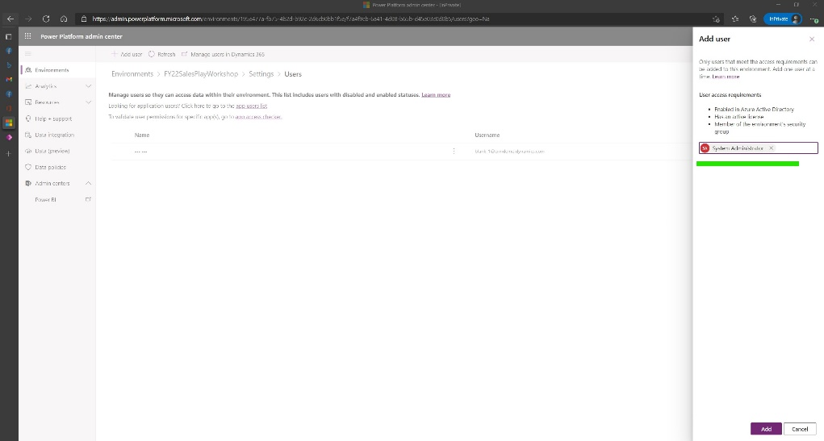
3. Assign this security roles to the user that you select earlier :
   1. Omnichannel Administrator
   2. Omnichannel Agent
   3. Omnichannel supervisor

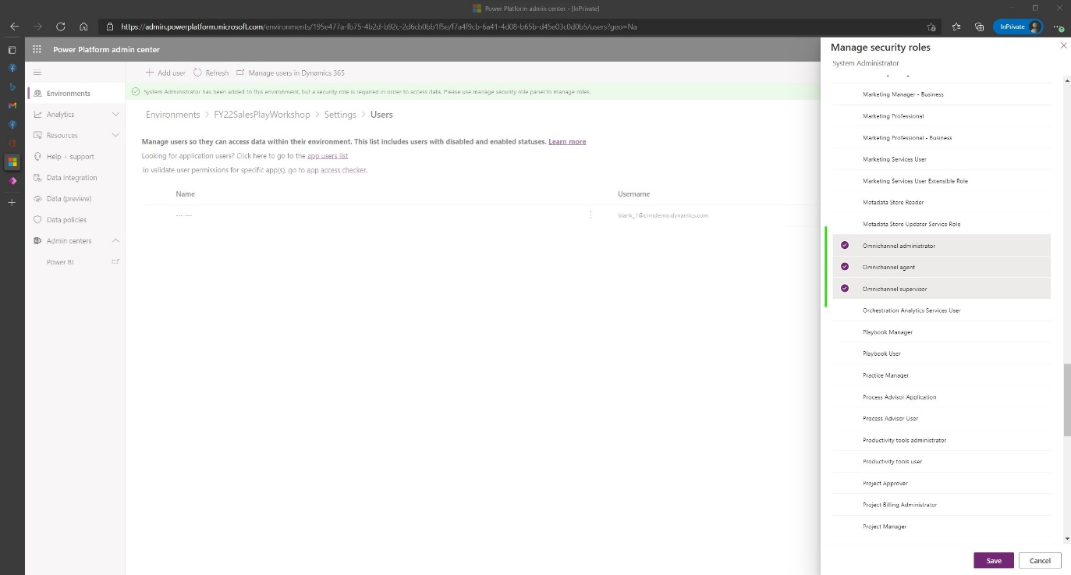

1. You have finished assigning required roles to setup and operate Dynamics 365 Omnichannel

## *Task 2 : Omnichannel Setup*

1. Go to make.powerapps.com, navigate to Apps 🡪 Omnichannel Administration  
     
   Table

   Description automatically generated
2. Navigate to Facebook 🡪 New  
     
   Graphical user interface, application, Word

   Description automatically generated
3. Open your Facebook Developer Page, and Get the ‘App ID’ and ‘App Secret’  
     
   Graphical user interface, text, application, email

   Description automatically generated
4. Copy and paste the ‘App ID’ and ‘App Secret’ to the ‘New Facebook Application’ in Dynamics 365 Omnichannel. Give it a name, and click ‘Save’  
     
   Graphical user interface, text, application, email

   Description automatically generated
5. On your newly created ‘Facebook Application’, Click ‘New Facebook Page’  
     
   Graphical user interface, text, application, email

   Description automatically generated
6. Open your Facebook Developer page, navigate to Messenger 🡪 Settings. Under ‘Access Tokens’, you will find your ‘Page ID’ and ‘Token’. Copy both of this.  
     
   Graphical user interface, text, application

   Description automatically generated
7. Copy and paste the ‘Page ID’ and ‘Tokens’ to the ‘New Facebook Page’ in Dynamics 365 Omnichannel. Choose the Workstream, and click Save.  
     
   Graphical user interface, text, application, email

   Description automatically generated
8. Go back to you ‘Facebook Application’ in Dynamics 365 Omnichannel. You should see the ‘Callback Uri’ and ‘Verify Token’ is already populated.  
     
   Graphical user interface, text, application, email

   Description automatically generated
9. Go back to your Facebook Developer and navigate to Messenger 🡪 Settings. On Webhook Tab, click ‘Add Callback URL’.  
     
   Graphical user interface, text, application, email

   Description automatically generated
10. After you finish adding, you should be able to see this.  
      
    Graphical user interface, text, application, email

    Description automatically generated
11. Switch back to Dynamics 365 Omnichannel. Click your newly created Facebook page.  
      
    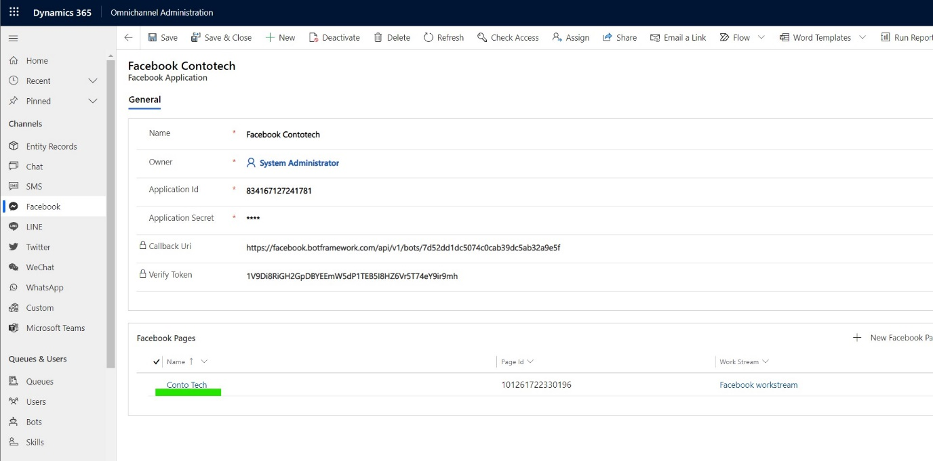
12. Take a note in the provisioning history. If it already populated, then you are on the right track. Click the ‘Facebook Workstream’.  
      
    Graphical user interface, text, application

    Description automatically generated
13. Inside ‘Facebook Workstream’, navigate to ‘Routing Rules’.  
      
    Graphical user interface, text, application, email

    Description automatically generated
14. Add new Routing Rules.  
      
    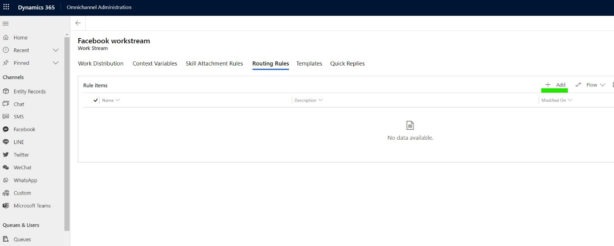
15. Fill out the ‘General Information’ and ‘Condition’ with data like in this screenshot. And click save.  
      
    Graphical user interface, application, table

    Description automatically generated
16. Click to the ‘Queue’  
      
    Graphical user interface, application, table

    Description automatically generated
17. Inside ‘Queue’ add a new user, and assign your username to it.  
      
    Graphical user interface, application

    Description automatically generated  
      
    Graphical user interface, text, application

    Description automatically generated
18. You have finished setting up your Dynamics 365 Omnichannel to be able to communicate with Facebook Messenger.

## *Task 3 : Testing the result by triggering chat from Facebook and then create a case.*

1. Go to make.powerapps.com, navigate to Apps 🡪 Omnichannel for Customer Service  
     
   Graphical user interface, table

   Description automatically generated
2. Switch to your Facebook Account, Click on ‘Pages’  
     
   Graphical user interface, text, application

   Description automatically generated
3. On your Facebook organization page, click ‘Send Message’ to initiate a message. Write something in the chat window.  
     
   Graphical user interface, application

   Description automatically generated
4. Switch back to Dynamics 365 Omnichannel for Customer Service page. You should get an incoming message notification.  
     
   Graphical user interface, application

   Description automatically generated

1. On the right side, you can click ‘New Case’.  
     
   Graphical user interface, application

   Description automatically generated
2. Fill out the new case details, and click save.  
     
   Graphical user interface, application

   Description automatically generated
3. Congratulations! You have created a connection from Facebook Messenger to Dynamics 365 Omnichannel and create a case ticket from it.